MarcelaH
[Email address]
Abstract
[Draw your reader in with an engaging abstract. It is typically a short summary of the document.
When you’re ready to add your content, just click here and start typing.]
[Document title]
[Document subtitle]

Contents
1 Computer hardware 2
1.1 Personal computers 2
1.2 Short overview of the development of microprocessors 3
2 Computer memory 4

1 Computer hardware
The computer can be described as a device that is capable of performing the requested data transformation. From other simpler calculating machines, the computer differs by high speed performance, ability to utilize internal memory and work according to the program stored in the memory.
The revolutionary idea that computers could be controlled by program invented Charles Babbage. The specific method of implementation of this idea was developed gradually. The first idea was that the computer program is recorded on some external recording medium (punched tape, punch card, etc.) and the base unit sequentially reads, decodes and immediately executes the program. This approach leads to variety of problems, for example slow and difficult calling of subroutines, the need to rewind the tape when jump commands in the program called another place, etc. This was caused by the sequential memory type used to store the program.
Later, John von Neumann proposed to store a program in such a way that the entire program is permanently available. He suggested loading the program into a memory that is not sequential, but behaves like a random access memory. This type of computer is called computer with internal management that means computer memory stores not only data that are processed, also the program that manages the data processing. An important idea which prevails in within the von Neumann architecture is the principle that the computer should not be adapted to specific application needs by internal structure, but only programs. This means that the internal structure of the computer should not be changed and should be versatile in order to fulfill a wide variety of applications. All activities associated with the specific problem solution should be accomplished at the programing level. Von Neumann's concept is designed to be universal and it could be programmed for virtually everything (Tanenbaum, Wetherall, 2011).

1.1 Personal computers
The term "personal computer" was introduced in 1981 by IBM, marking the microcomputer PC (Personal Computer). These computers belong to a broader group of microcomputers. Their architecture is based on the Von Neumann concept, which is a computer with an internal management. A diagram of Von Neumann's concept computer represents Figure 3.1.
The main part that contains "control unit", "ALU" (ALU - Arithmetic-Logic Unit) and registers is called the processor, or Central Processing Unit, in short CPU.
Microprocessor is a word consisting of two parts, micro and processor, which indicates that the processor as defined above is made ​​utilizing miniaturization of the electronic circuits, microprocessor is an integrated circuit with a high degree of integration (VLSI - Very Large Scale Integration, ELSI - Extra Large Scale Integration). The microprocessor is constructed to communicate with the memory using memory bus and devices using input-output interface that is located usually outside the chip. The microprocessor in connection with memory (RWM - Read Write Memory, ROM - Read Only Memory), input-output interface and other auxiliary circuit (clock generator, power supply) is a microcomputer.
Figure 1 Von Neumann concept
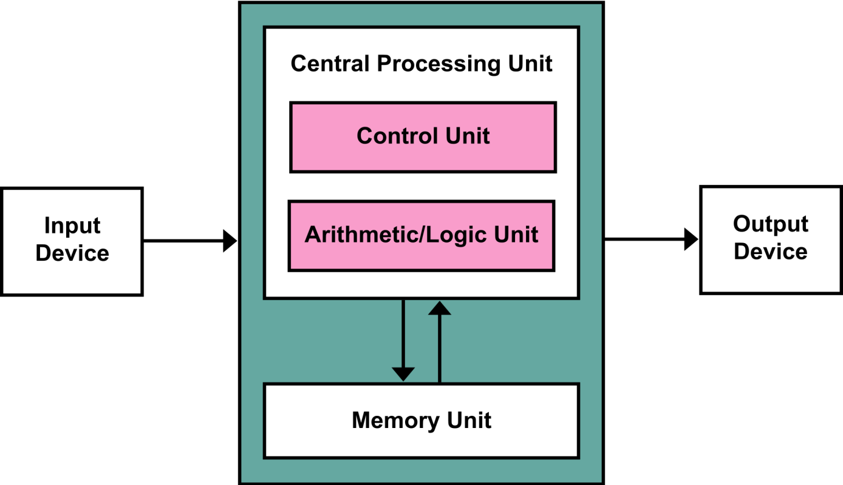

Microprocessors opened up new possibilities in the design and construction of digital circuits and systems. Initially, the microprocessor is used as one of the subsystems in the terminals, calculating and communication devices, but in 1974, two years after its production, there was a real boom in the use of microprocessors. Number of produced microprocessors exceeded the sum of all existing minicomputers, medium and large scale computers. Microprocessors have changed design and functionality of traditional digital systems because of its low cost, great flexibility and reliability. The main area of microcomputer utilization is computing.

1.2 Short overview of the development of microprocessors
The first use of the term "microprocessor" is attributed to Viatron Computer Systems describing the custom integrated circuit used in their System 21 small computer system announced in 1968.

Intel introduced its first 4-bit microprocessor 4004 in 1971 and its 8-bit microprocessor 8008 in 1972. During the 1960s, computer processors were constructed out of small and medium-scale ICs—each containing from tens of transistors to a few hundred. These were placed and soldered onto printed circuit boards, and often multiple boards were interconnected in a chassis. The large number of discrete logic gates used more electrical power—and therefore produced more heat—than a more integrated design with fewer ICs. The distance that signals had to travel between ICs on the boards limited a computer's operating speed (Babcock, 2006).

In the NASA Apollo space missions to the moon in the 1960s and 1970s, all on board computations for primary guidance, navigation and control were provided by a small custom processor called "The Apollo Guidance Computer". It used wire wrap circuit boards whose only logic elements were three-input NOR gates.

The first microprocessors emerged in the early 1970s and were used for electronic calculators, using binary-coded decimal (BCD) arithmetic on 4-bit words. Other embedded uses of 4-bit and 8-bit microprocessors, such as terminals, printers, various kinds of automation etc., followed soon after. Affordable 8-bit microprocessors with 16-bit addressing also led to the first general-purpose microcomputers from the mid-1970s on.

Since the early 1970s, the increase in capacity of microprocessors has followed Moore's law; this originally suggested that the number of components that can be fitted onto a chip doubles every year. With present technology, it is actually every two years, and as such Moore later changed the period to two years (Computer software,2002).

2 Computer memory
Computer data storage, often called storage or memory, is a technology consisting of computer components and recording media used to retain digital data. It is a core function and fundamental component of computers. The central processing unit (CPU) of a computer is what manipulates data by performing computations.
In practice, almost all computers use a storage hierarchy, which puts fast but expensive and small storage options close to the CPU and slower but larger and cheaper options farther away. Often the fast, volatile technologies (which lose data when powered off) are referred to as "memory", while slower permanent technologies are referred to as "storage", but these terms are often used interchangeably.
Andrew S. Tanenbaum, David J. Wetherall. 2011. “Computer networks, 5th ed.” [Online]. http://cse.hcmut.edu.vn/~minhnguyen/NET/Computer%20Networks%20-%20A%20Tanenbaum%20-%205th%20edition.pdf . ISBN-13: 978-0-13-212695-3
Babcock, Ch. 2006. "What's The Greatest Software Ever Written?", [online]. http://www.informationweek.com/whats-the-greatest-software-ever-written/d/did /1046033?
“Computer software” 2002. [Online] http://www.wiley.com/college/turban/0471073806/sc/ch04.pdf

