DIPLOMA

of participation
on faculty Student Scientific Conference for

Surname Name

in session International and Sustainable Business
Predseda komisie
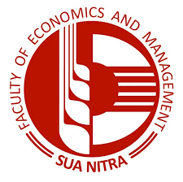
Faculty
of Economics
and Management
Vice-dean for Education
Nitra, April 25, 2018
Chairperson
Slovak
University
of Agriculture
in Nitra

